BUSINESSES FOR SALE

MARCH 14, 2025

If you are interested in any of the listings below, please complete the Non-Disclosure/Non-Circumvention Agreement and the Buyer Information Form found at the end of this document on pages A-1 and A-2, and return them by e-mail. Make sure that the second page is fully completed, including listing the businesses you are interested in and the requested personal financial information. The signed Agreement must be returned before we will release any specific information.

HOME HEALTH CARE BUSINESSES


CALL AND ASK FOR INFORMATION.

BARS PHILADELPHIA

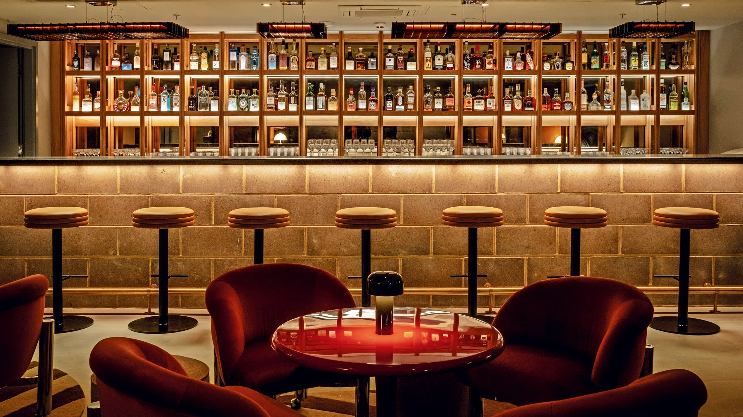

9A. UNDER AGREEMENT

9B. BAR PHILADELPHIA WITH REAL ESTATE INCLUDING FOUR APARTMENTS. ASKING 800,000.
GROSS SALES 3,500 A WEEK.

9C. BAR PHILADELPHIA GROSSING 6,000 A WEEK PLUS ADDITIONAL INCOME FROM VENDING MACHINES
WITH APARTMENT ABOVE. ASKING 500,000 WITH REAL ESTATE AND LICENSE.

9D. SOLD

9E. BAR PHILADELPHIA ASKING 785,000 INCLUDING VALUABLE REAL ESTATE AND LICENSES. GROSSING
7,500 PER WEEK.

9F. BAR FOR SALE FISHTOWN SECTION OF PHILADELPHIA. THIS OPPORTUNITY INCLUDES
BUSINESS, LIQUOR LICENSE, ONE THREE BEDROOM APARTMENT AND ALSO INCLUDES HOUSE NEXT
TO THE BAR. GROSS 500,000 A YEAR AND 50,000 IN VENDING INCOME. ASKING 1,000,000.

9G. BAR PHILADELPHIA GROSSING 6,000 A WEEK WITH 16 ROOMS TWELVE ARE RENTED THAT GENERATE
4,321 MONTHLY. ASKING $680,000.

BEER DISTRIBUTORS

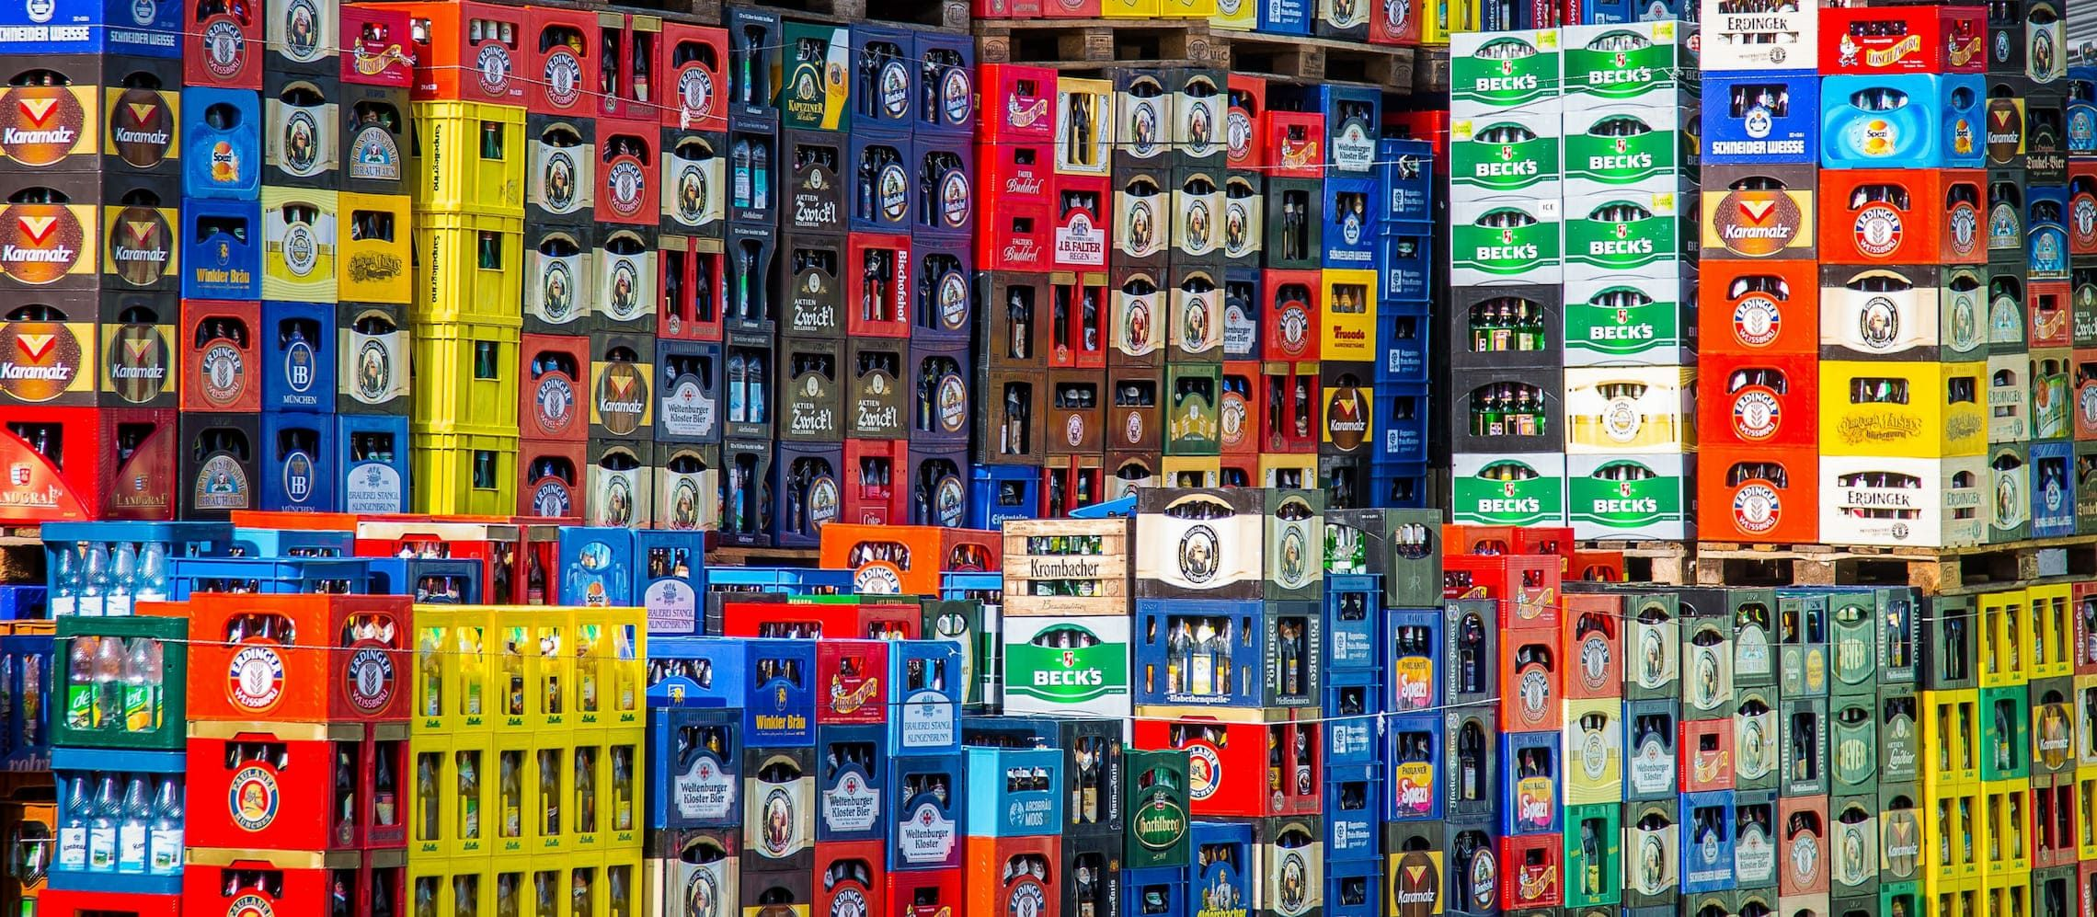

- GO GO BAR PHILADELPHIA GROSSING 860,000. OWNER OPERATOR WILL MAKE A LOT OF MONEY. BUSINESS CAN BE BOUGHT FOR 900,000 AND PROPERTY COULD BE AVAILABLE. SELLER IS WILLING TO DO SOME FINANCING.

- SOLD

- BEER DISTRIBUTOR GROSSING 1,300,000 AND ASKING 950,000 WITH LOTTERY COMMISSION OF 53,000. RENT IS 4,000 IN 2,800 SQUARE FEET. PHILADELPHIA.

BARS FOR SALE DELAWARE COUNTY



- BAR WITH REAL ESTATE GROSSING 8,000 A WEEK PLUS RENTAL OF KITCHEN 500 A MONTH. VALUABLE REAL ESTATE WITH FOUR ONE BEDROOM APARTMENTS THAT BRING IN 3,200 A MONTH. ONLY ASKING 895,000.

21A. BAR DELAWARE COUNTY ASKING 500,000 WITHOUT REAL ESTATE. GROSSING OVER 500,000.

21B. BAR DELAWARE COUNTY ASKING 1,700,000 WITH LICENSE AND VALUABLE REAL ESTATE.

- BAR DELAWARE COUNTY WITHOUT REAL ESTATE. GROSSING 25,000 A WEEK WITH 15% FOOD. HIGH PROFIT BAR. ONLY ASKING 675,000 WITH RENT OF 3,700

DELI WITH AND WITHOUT BEER

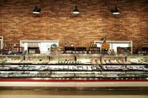

- BREAKFAST AND LUNCH ONLY FIVE DAYS A WEEK. CLOSED MONDAY AND TUESDAY. OPENS AT 8 AND CLOSES AT 2PM. YEARLY GROSS IS CLOSE TO 1,500,000 AND ONLY ASKING 800,000. LOCATED IN THE GREAT PART OF DELAWARE COUNTY, PA.

- BEER DELI DELAWARE COUNTY. GROSSING 1,300,000 WITH HIGH PROFIT. ASKING 1,000,000 FOR BUSINESS AND 1,200,000 FOR REAL ESTATE.

- SOLD

- BEER DELI CHESTER COUNTY GROSSING 14,000 A WEEK. ASKING 975,000 WITH VALUABLE E LICENSE. THE CURRENT RENT IS 1,800 INCLUDING CAM.

- DELI IN CHESTER COUNTY GROSSING 7,500 PER WEEK. ONLY ASKING 275,000. RENT IS 2,380 PLUS CAM.

- BEER DELI IN STRIP CENTER DELAWARE COUNTY. GROSSING 1,000,000 AND ONLY ASKING 595,000. RENT IS 3,200 PLUS CAM. HOURS 8:30 TO 10.

- BEER DELI WITH REAL ESTATE DELAWARE COUNTY. GROSSING 850,000 (50%) BEER. LOTTERY 12,000. ASKING 675,000.

- BEER DELI WITH REAL ESTATE INCLUDING RENTAL APARTMENT IN DELAWARE COUNTY. GROSSES 30,000 A MONTH (65%) BEER PLUS 10,000 IN LOTTERY. RENTAL INCOME OF 800.00 ASKING 395,000

PIZZA AND HOAGIES



- PIZZA PHILADELPHIA GROSSING 500,000 AND ONLY ASKING 99,000. RENT OF 2,350.

- PIZZA PHILADELPHIA GROSSING 700,000 WITH ALL UPDATED EQUIPMENT. 30% DELIVERY. ASKING 575,000.

- PIZZA DELAWARE COUNTY ONLY ASKING 70,000 WITH RENT OF 2,400. OWNER TIRED AND MOTIVATED TO SELL. GROSSING 250,000 A YEAR.

- PIZZA DELAWARE COUNTY WITH REAL ESTATE. GROSSING 950,000 AND ASKING 700,000.

- BEST HOAGIES IN PHILLY. GROSSING OVER 35,000 A MONTH AND ONLY WORKING 4 DAYS A WEEK. FOOTBALL SEASON WORKS ½ DAY ON SUNDAY. ONLY ASKING 250,000.

- PROFITABLE PIZZERIA WITH BEER LOGAN SQUARE SECTION OF CENTER CITY. GROSS SALES OF 11,000 A WEEK OF WHICH 35% DELIVERY. ASKING 380,000. CURRENT (ABSENTEE) OWNERS DO NO MARKETING.

- HOAGIES BUCKS COUNTY FRANCHISE HOWEVER YOU CAN CHANGE NAME. GROSSING 290,000 WITH RENT OF 2,895. ASKING ONLY 80,000

- PIZZA PHILADELPHIA (BEING UPDATED)

- PIZZA MONTGOMERY COUNTY. GROSSING 800,000 AND ASKING 430,000. RENT 4,500.

CONVENIENCE STORES

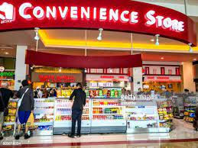

- CONVENIENCE STORE IN SOUTH PHILADELPHIA GROSSING 475,000 WITH LOTTERY COMMISSION OF 43,000 PLUS UPS COMMISSION OF 2,900. ONLY ASKING 260,000 PLUS TOBACCO INVENTORY OF 40,000 WITH RENT OF 1,150.

- CONVENIENCE STORE DELAWARE COUNTY GROSSING 55,000 A MONTH WITH LOTTERY COMMISSION OF 35,000. ASKING 650,000 WITH VALUABLE REAL ESTATE.
63.

64.

65. MINI-MARKET PHILADELPHIA GROSSING OVER 1,000,000 WITH ADDITIONAL INCOME OF 54,000 LOTTERY, SKILLED MACHINES 100,000 AND ATM 36,000. ONLY ASKING 550,000 PLUS INVENTORY OF 150,000. RENT IS 5,000

66.

67.

68.

69.

CAR WASHES

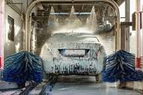

- CAR WASH RECENTLY RENOVATED EXTERIOR ONLY WITH 127 FOOT TUNNEL ON BUSY STREET. REVENUE IN 2022 WAS 384,000. ASKING 1,000,000 WITH RENT OF 6,000. PROPERTY CAN BE PURCHASED. LOCATED IN CHESTER COUNTY.

- FULL SERVICE FOR OVER 26 YEARS. CAR WASH DOES NOT RECYCLE WATER. THIS IS A UNIQUE CAR WASH AND THAT IS WHY THE CUSTOMERS COME BACK. TUNNEL FEATURES INDUSTRY LEADING PRODUCTS, WHICH HAVE SUPERIOR CLEANING PERFORMANCE PRESSURE BLASTERS TO CLEAN YOUR UNDERCARRIAGE. ASKING 2,000,000 WITHOUT REAL ESTATE.

BARS MONTGOMERY, CHESTER AND BUCKS

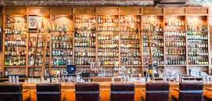

- BAR BUCKS COUNTY GROSSING 600,000 WITH VALUABLE LICENSE. ASKING 575,000 WITH RENT OF 4,500 A MONTH.

- BAR CHESTER COUNTY WITH REAL ESTATE AND VALUABLE LICENSE. GROSSING 6,500 A WEEK ONLY ASKING 850,000.

- BAR MONTGOMERY COUNTY GROSSING 2,300,000 ASKING 1,400,000 WITH REAL ESTATE.

- BAR MONTGOMERY COUNTY IN 5,000 SQUARE FEET. ASKING 700,000 WITH GROSS SALES OF 960,000. RENT IS 7,500.

84.

BARS DELAWARE COUNTY

85a. BAR DELAWARE COUNTY GROSSING 400,000 AND ASKING 875,000 FOR BUSINESS,
“R” LICENSE AND REAL ESTATE.

85b. BAR DELAWARE COUNTY GROSSING 200,000 ASKING 950,000 INCLUDING,
BUSINESS, “R” LICENSE AND REAL ESTATE.

85c. BAR DELAWARE COUNTY GROSSING 1,200,000 AND ONLY ASKING 1,850,000 FOR
BUSINESS, “R” LICENSE AND REAL ESTATE.

85D. BAR DELAWARE COUNTY GROSSING 650,000 WITH RENT OF 2,200. ASKING 350,000 MOTIVATED SELLER.

MISCELLANEOUS

86. ENVIRONMENTAL BUSINESS PENNSYLVANIA GROSSING 500,000 AND ONLY ASKING 475,000.

- FOOD WHOLESALER PHILADELPHIA GROSSING OVER 12,000,000 CAN BE BOUGHT WITH OR WITHOUT WAREHOUSE. ASKING 5,100,000 INCLUDING 2,000,000 OF INVENTORY AND ACCOUNTS RECEIVABLES OF 1,000,000. OWNER WILL STAY TO HELP GROW.

- DRY CLEANING PLANT PHILADELPHIA GROSSING 3,500 RETAIL AND 2,500 WHOLESALE. RENT IS 4,000 INCLUDING CAM. SELLER ONLY ASKING 175,000.

- DRY CLEANING PLANT IN MONTGOMERY COUNTY. GROSSING 3,500 RETAIL AND 4,000 WHOLESALE. ASKING 250,000 WITH RENT OF 4,000 INCLUDING CAM IN STRIP CENTER.

- LAUNDROMAT NORTHEAST PHILADELPHIA GROSSING 120,000 ASKING 595,000 WITH PROPERTY.

- USED CAR LOT IN BUCKS COUNTY. CAN BE BOUGHT WITH OR WITHOUT REAL ESTATE. GROSSES 4,827,000 PER YEAR. ASKING 500,000 FOR BUSINESS.

- INSURANCE AND BONDS PHILADELPHIA. GROSSING 300,000 AND ASKING 500,000. OPEN MONDAY THRU THURSDAY 10 TO 5.

- OUTDOOR NEWSSTAND OPEN 6 DAYS A WEEK FROM 11 TO 6:30. LOTTERY COMMISSION OF 54,000 AND STAND SALES ARE 150,000. SIGN RENTAL 8,500. ASKING 120,000.

- SMOKE SHOP PHILADELPHIA GROSSING 250,000 AND ASKING 150,000. LOTTERY COMMISSION 12,000.

- OUTDOOR NEWSSTAND PHILADELPHIA. DOING 3,000 A WEEK AND 42,000 LOTTERY. ASKING 65,000.

- NEWS AND TOBACCO DELAWARE. GROSSING 1,250,000 WITH RENT OF 2,400 TRIPLE NET. LOTTERY COMMISSION IS 12,500. MONDAY THRU SUNDAY 10 TO 6. ASKING 500,000 PLUS INVENTORY.

- BAGELS AND DELI CENTRAL NEW JERSEY. GROSSING 625,000 OF WHICH 40% WHOLESALE. ASKING 395,000.

- RESTAURANT IN DELAWARE COUNTY WITH REAL ESTATE AND THREE APARTMENTS. GROSSING 2,000,000 AND ASKING 1,500,000.

LIQUOR LICENSES AVAILABLE
- Looking for a Beer/Alcohol license? We can find one for you! Call us!

 | 50 Belmont Avenue 1004, Bala Cynwyd, PA 19004  610-667-6648  www.shermangroup.net  sherman@shermangroup.net

NON-DISCLOSURE / NON-CIRCUMVENTION AGREEMENT
Non-Disclosure Agreement: The undersigned hereby certifies that any and all information provided by THE SHERMAN GROUP with respect to any corporation, partnership, or entity (hereinafter, Companies) for the purpose of considering such Companies for the purchase will be kept confidential. This information will remain the property of THE SHERMAN GROUP; it will be kept in my possession and will not be divulged to any party except to those whose knowledge of the information is required to evaluate the Companies as potential acquisitions and who shall assume the same obligations as set forth in this letter, without prior written approval from The Sherman Group.

It is further understood that the purpose of this letter is to protect the Companies that THE SHERMAN GROUP is offering for sale. The Companies ability to remain competitive within their marketplace hinges upon their success in keeping any thought of a sale from reaching their suppliers, customers and employees. Thus, all conversations and documents shall be held in strict confidence and discussed solely with agents of THE SHERMAN GROUP, as representatives of the Companies

It is understood that (a) The Sherman Group makes no representation or warranty as to the completeness or accuracy as to any information and (b) any and all representations and warranties shall be made solely by the Company and shall be set forth in a signed purchase contract and then be subject to the provisions thereof. The undersigned acknowledges the responsibility to perform a due diligence review at my own cost and expense prior to any acquisition of said Company.

It is the Seller’s responsibility to pay the broker’s fee, however, I agree that if I should purchase the below mentioned business(es) and/or property(es) or enter into a lease purchase agreement within twenty (24) months of the date it was introduced to me by The Sherman Group, and I fail to make such purchase or lease purchase through THE SHERMAN GROUP, I shall be liable to The Sherman Group for a commission equal to ten percent (10%) of the purchase price or aggregate lease payments. If I fail to comply with the terms set forth herein, I agree to become personally liable for the commissions that would have become due to THE SHERMAN GROUP.

I have read and understand the contents hereof. This agreement expires twenty-four (24) months from the date listed below.
Prospective Buyer’s Legal Name | Signature | Date
REMINDER: OUR SELLERS DO NOT WANT THEIR STAFF OR THE PUBLIC TO KNOW THAT THEY ARE TRYING TO SELL THEIR BUSINESSES. THEREFORE YOU ARE NOT PERMITTED TO SPEAK DIRECTLY WITH ANYONE AT ANY BUSINESS INTRODUCED TO YOU BY THE SHERMAN GROUP UNLESS ARRANGEMENTS HAVE BEEN MADE BY US BEFOREHAND.

5o Belmont Avenue 1004, Bala Cynwyd, PA 19004
610-667-6648
www.shermangroup.net
sherman@shermangroup.net
BUYER INFORMATION FORM
Name:
 | Last | First | M.I.

Address:
 | Street Address | Apartment/Unit #

 | City | State | ZIP Code

Cellular Phone: |  | Alternate Phone:

Email Address:

Occupation:

BUSINESS INFORMATION

Have you owned a business before? |  | If yes, what type?

What types of businesses are
you interested in purchasing?

Owner-Operator or Absentee Owner? |  | Timeframe for Decision

financial INFORMATION

How much cash do you have available to invest in a business? (Do not include loans or financing.)

Maximum Price of Business |  | Minimum Gross Revenue Requirements?

Businesses you are interested in:
(Use our listing numbers and/or descriptions)

